Command w,who,whoami
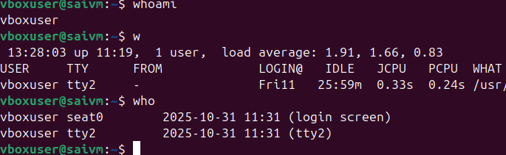
Command: ls
Description: Lists files and directories in the current directory.
Example: ls will display files and folders in your current directory, and ls -l provides detailed information
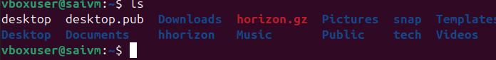
Command: ip a
Description: Lists your IP address and network interfaces.
Example: ip a shows all network interfaces and their IP addresses
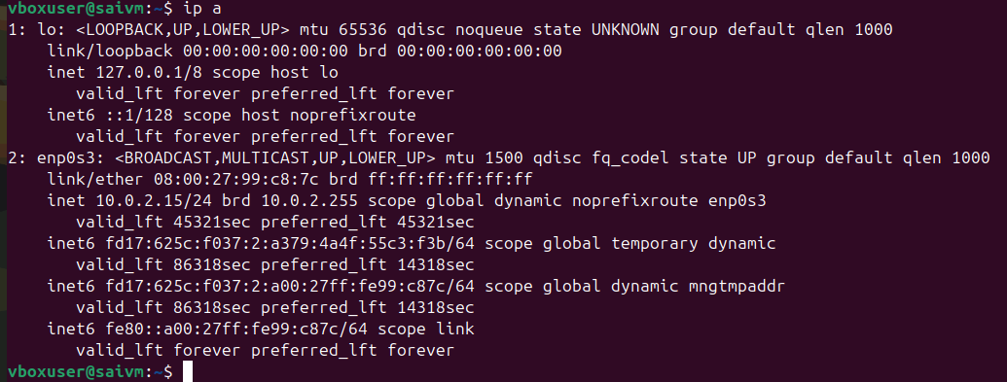

Command: cat
Description: Reads the contents of text files.
Example: cat myfile.txt will display the content of myfile.txt
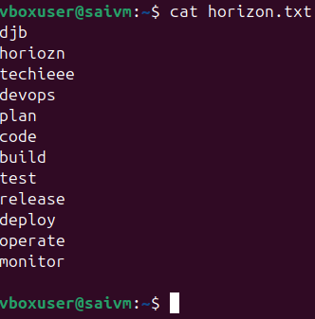

Command: passwd
Description: Used to change the password of the user account.
Example: Typing passwd and following the prompts will allow you to change your password
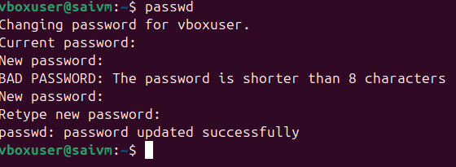

Command: touch
Description: Creates empty files, mainly useful to test write ability.
Example: touch newfile.txt creates an empty file named newfile.txt.

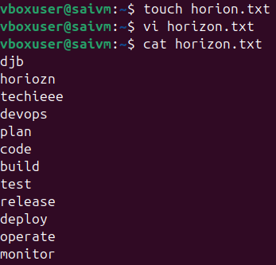
Command: pwd
Description: Stands for Print Working Directory; shows which directory you are in.
Example: Running pwd might return /home/john_doe.

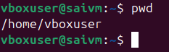
Command: man
Description: Accesses the system documentation for commands.
Example: man ls will show the manual for the ls command

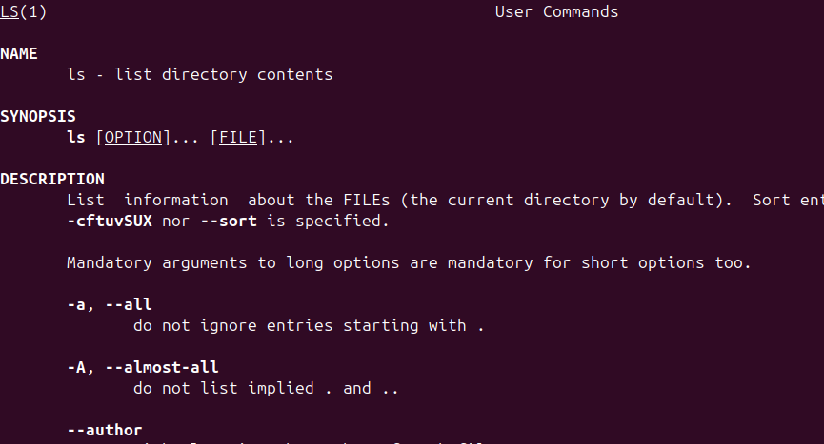
Command: apropos
Description: Searches commands related to a specific task based on description (equivalent to man -k).
Example: apropos "list files" might return commands related to listing files
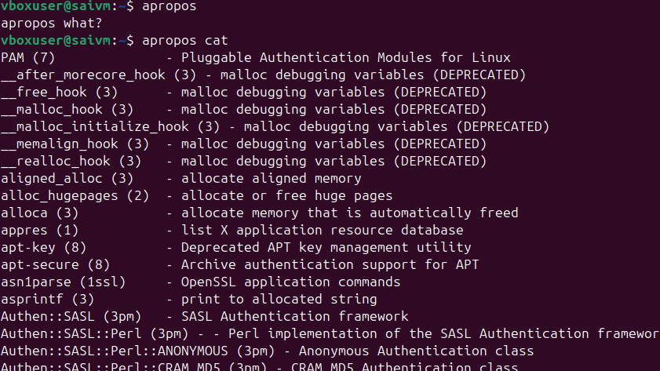

Command: pinfo
Description: Provides additional information, similar to man.
Example: pinfo ls gives detailed information about the ls command
Command : pinfo pinfo
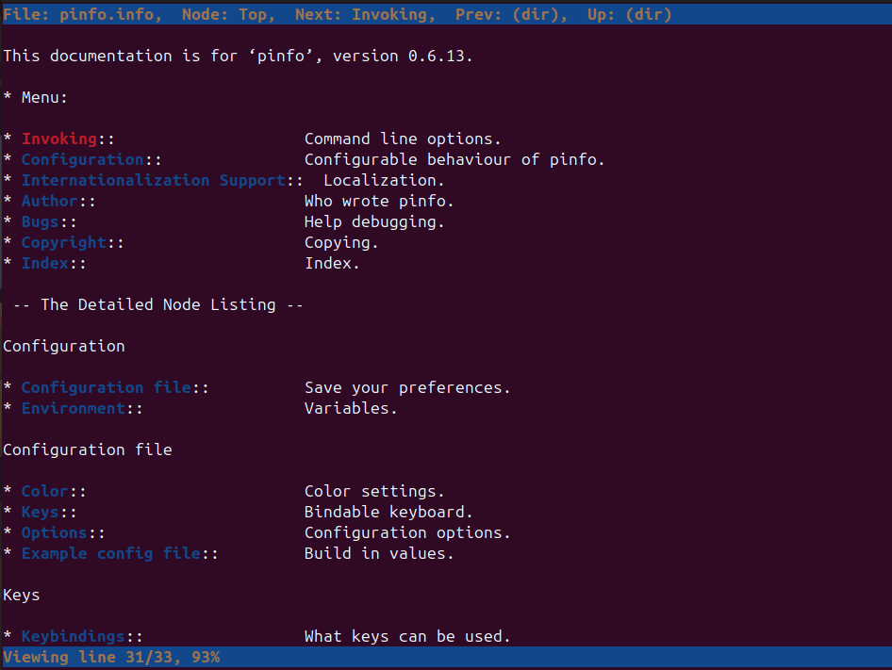
Pinfo ls
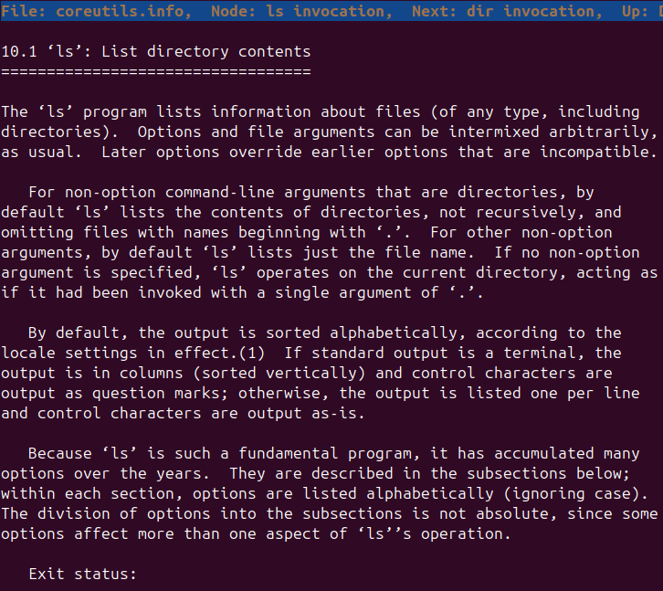

Essential File Management Tools Commands
Command: ls
Example: ls /home/user/Documents
Description: Lists files and directories within a specified path. This command is used to view the contents of directories
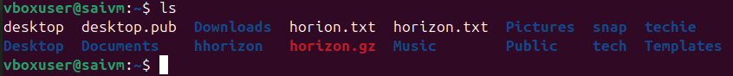

Command: cp
Example: cp source.txt destination.txt
Description: Copies files from one location to another. This command is used to make duplicates of files
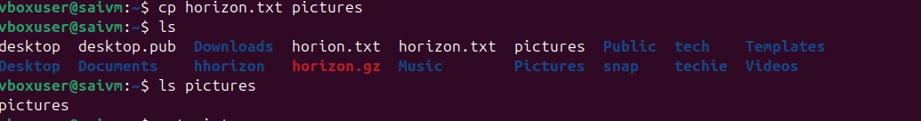
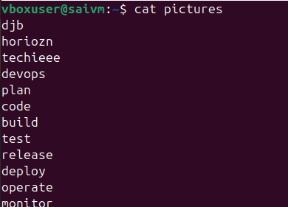

Command: mkdir
Example: mkdir new_directory
Description: Creates a new directory. This command is used when you need to make a new folder
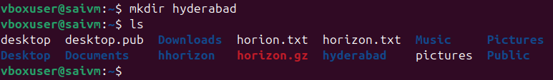

Command: rmdir
Example: rmdir empty_directory
Description: Removes a directory, but only if it's empty. This command is used for deleting empty folders
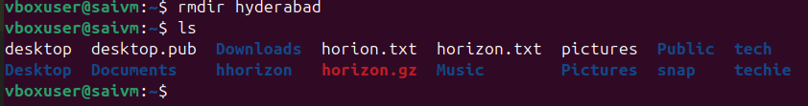

Command: mv
Example: mv oldname.txt newname.txt
Description: Moves or renames files and directories. This command can change the location or the name of a file.
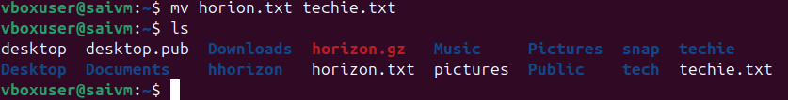

Command: rm
Example: rm filename.txt
Description: Removes files or directories. This command deletes files or directories.
Note: When combined with options -r (recursive) and -f (force), as in rm -rf directory_name, it becomes a powerful command that can delete directories and their contents without asking for confirmation
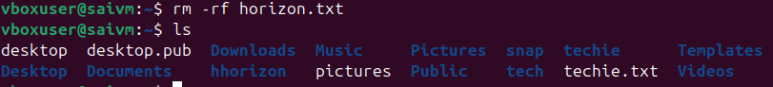

Advanced File Management Tools Commands
ln: Used for creating hard and symbolic links.
Example: ln -s source_file symbolic_link creates a symbolic link to source_file.
Description: Links a file or directory to another location
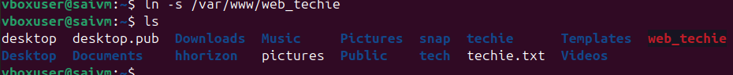
hard link
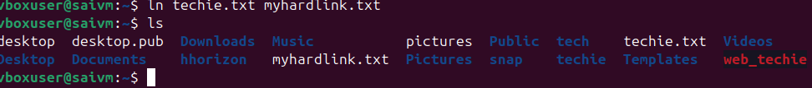

find: A utility to find files based on various properties.
Example: find /home -name "*.txt"searches for text files in the /home directory.
Description: Searches for files and directories in a given path
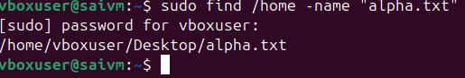
For searching files with .txt
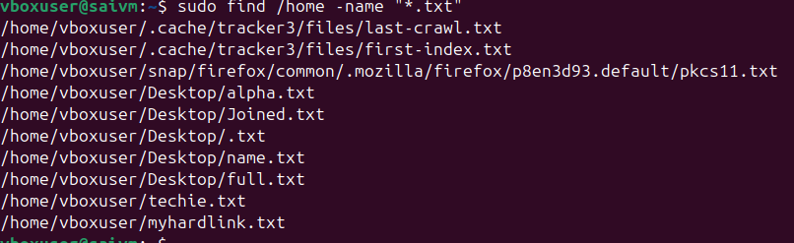

Files older than 7days
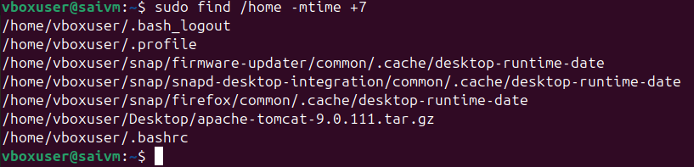
locate: Used for quickly searching the database of system's contents.
Example: locate filename finds the location of filename.
Description: Fast file searching, requires running updatedb for an updated database
We can use locate filename
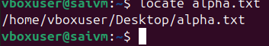
which: Finds the location of executables in the PATH.
Example: which python shows the path of the Python executable.
Description: Useful for finding executable files in system's PATH
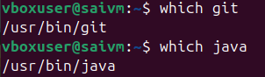
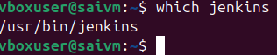

tar: Archives multiple files into a single file.
Example: tar -cvf archive.tar /foldercreates an archive of a folder.
Description: Combines multiple files into a tarball.
It stands for “tape archive”, and it’s one of the most common tools for compressing and backing up files.
• c → create a new archive x → Xtrat the archive
• v → verbose (show progress)
• f → file name of the archive
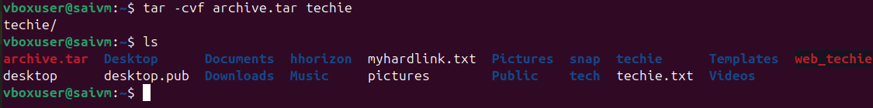
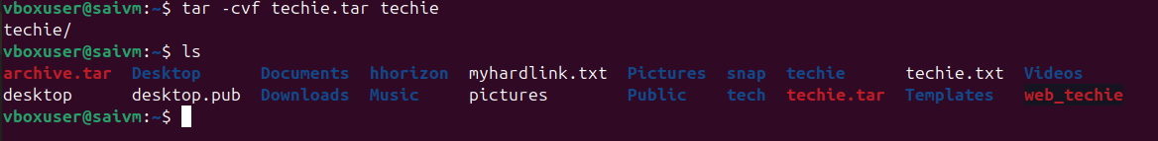
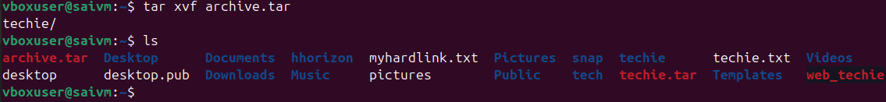

gzip : Compresses files.
Example: gzip file.txt compresses file.txt.
Description: Reduces the size of files using compression
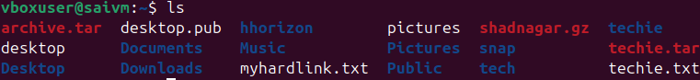

bzip2: A file compression utility.
Example: bzip2 file.txt compresses file.txt.
Description: Offers better compression ratios than gzip at the cost of speed
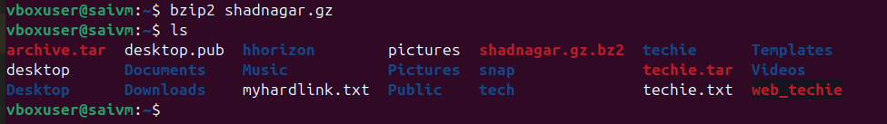
xz: High compression utility.
Example: xz file.txt compresses file.txt.
Description: Provides the best compression ratio.

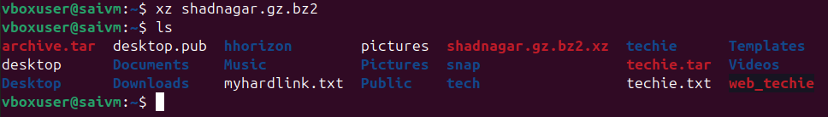

zip: Used for packaging and compressing (archiving) files.
Example: zip archive.zip file1 file2 creates an archive with file1 and file2.
Description: Commonly used for creating .zip files.

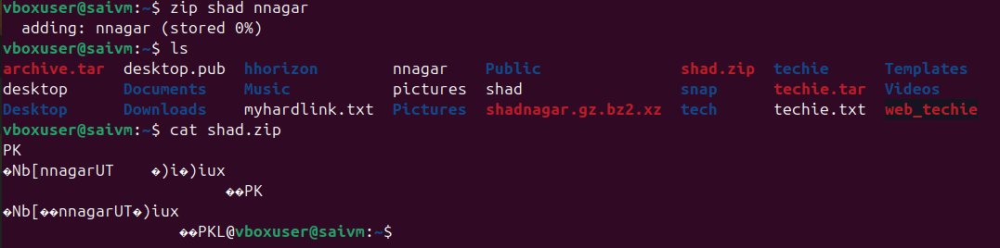

file: Determines the type of a file.
Example: file image.jpg displays the type of image.jpg.
Description: Useful for identifying file formats
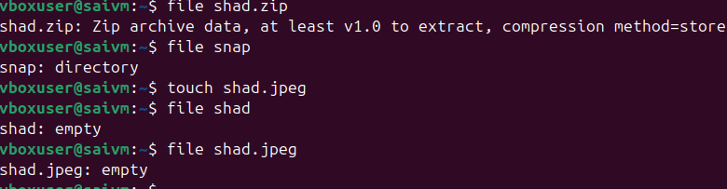

mount: Attaches a filesystem to a specified directory.
Example: mount /dev/sdb1 /mnt mounts the device sdb1 to /mnt.
Description: Used to access filesystems on different storage devices

df: Displays disk space usage of all mounted filesystems.
Example: df -h shows disk space in human-readable format.
Description: Useful for monitoring disk space usage.

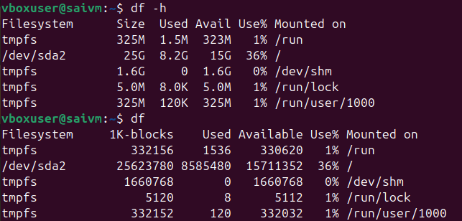

findmnt: Lists all mounted filesystems.
Example: findmnt -t ext4 lists all ext4 type mounts.
Description: Displays a tree-like structure of mounts

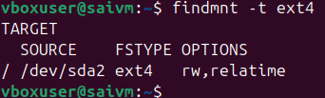

lsblk: Lists information about block devices.
Example: lsblk lists all block devices.
Description: Useful for identifying storage devices and their partitions

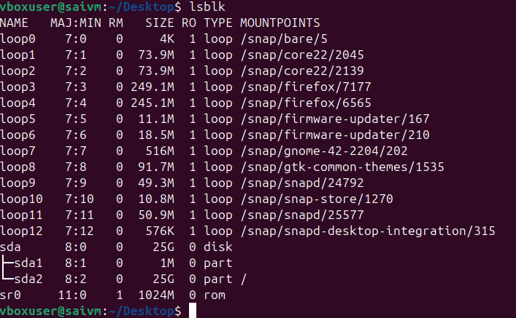

Working with Text Files Commands
Command : nano
Description: A user-friendly text editor.
Example: nano filename.txt - Opens filename.txt in nano editor.
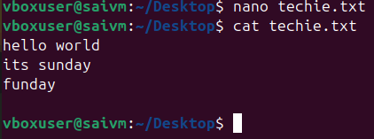

vimtutor
Description: A tutorial program for learning VIM, an advanced text editor.
Example: vimtutor - Starts the VIM tutorial.
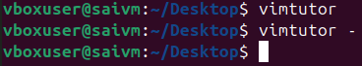

vi
Description: The original text editor, with basic features.
Example: vi filename.txt - Opens filename.txt in VI editor

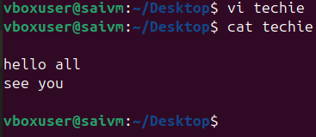

vim
Description: An improved version of VI with more features.
Example: vim filename.txt - Opens filename.txt in VIM editor.

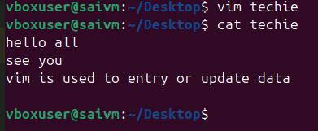
more
Description: A pager to view the contents of text files, one screen at a time.
Example: more filename.txt - Views the content of filename.txt.

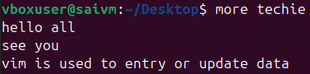
less
Description: Similar to more, but provides more control over viewing text files.
Example: less filename.txt - Opens filename.txt for viewing with navigation options
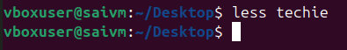
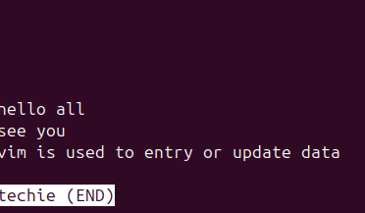

head
Description: Displays the first few lines of a text file.
Example: head filename.txt - Shows the top lines of filename.txt.
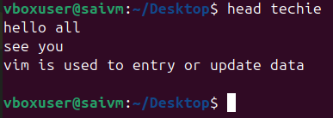

tail
Description: Displays the last few lines of a text file.
Example: tail filename.txt - Shows the last lines of filename.txt
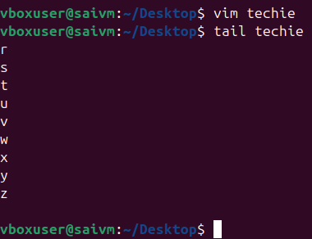

cat
Description: Concatenates and displays the entire content of text files.
Example: cat filename.txt - Displays the full content of filename.txt.
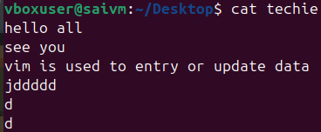

cat -A
Description: Similar to cat, but also displays special characters.
Example: cat -A filename.txt - Shows the content of filename.txt, including special characters
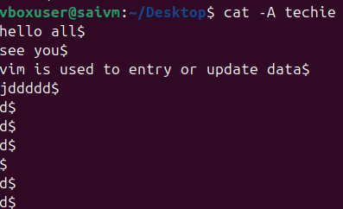

tac
Description: Prints the contents of a text file in reverse order.
Example: tac filename.txt - Displays filename.txt content backwards
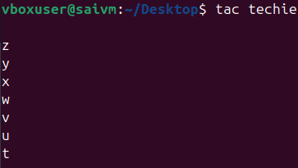
grep
Description: Searches for text in files or command output.
Example: grep 'pattern' filename.txt- Searches for 'pattern' in filename.txt
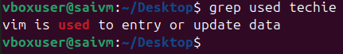
grep:
Command: "grep"
Example: grep 'pattern' file.txt
Description: Filters text in files by searching for specific patterns.
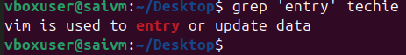
awk:
Command: "awk"
Example: "awk '/pattern/ {print}' file.txt"
Description: Filters and processes text, with additional features for text manipulation
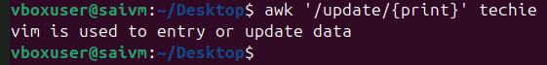
sed:
Command: "sed"
Example: "sed 's/old/new/' file.txt"
Description: A stream editor used for modifying text files directly from the command line
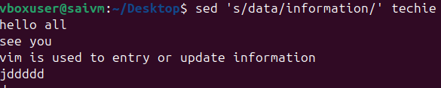
Command: "tr"
Example: "tr '[:lower:]' '[:upper:]' < file.txt"
Description: Translates or deletes characters from input text
• tr → translate or replace characters
• '[:lower:]' → all lowercase letters
• '[:upper:]' → all uppercase letters
• < inputfile → take input from a file
• > techie → save output to a new file

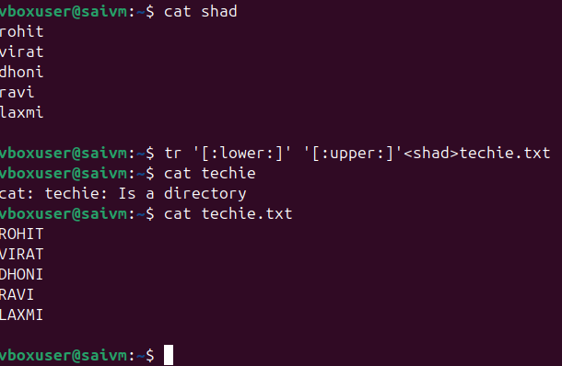
cut:
Command: "cut"
Example: "cut -d':' -f1 file.txt"
Description: Extracts sections from each line of files, such as columns from a table
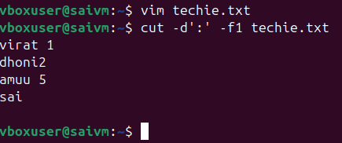
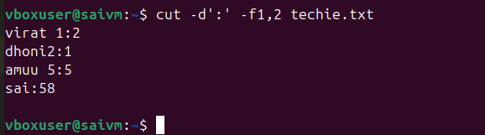

sort:
Command: "sort"
Example: "sort file.txt"
Description: Sorts text files in alphabetical or numerical order, as specified.
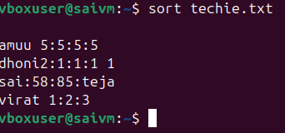

Connecting to a Server Commands
su Command
Example: su username
Description: This command is used to switch user identity in a Unix-like operating system. When you type su followed by a username, it prompts you for the password of that user and, if entered correctly, logs you in as that user.
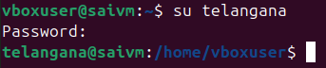
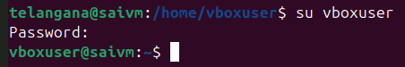
sudo Command
Example: sudo apt update
Description: The sudo command allows a permitted user to execute a command as the superuser or another user, as specified in the sudoers file. This example updates the list of available packages and their versions, but it requires administrative privileges, hence the use of sudo.
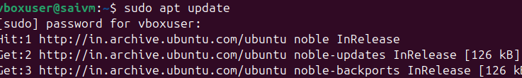

ssh Command
Example: ssh username@hostname
Description: ssh stands for Secure Shell. It's used to connect and log into a remote machine securely. The example shows how to connect to a remote host where username is your username on the remote machine, and hostname is the address of the remote machine.
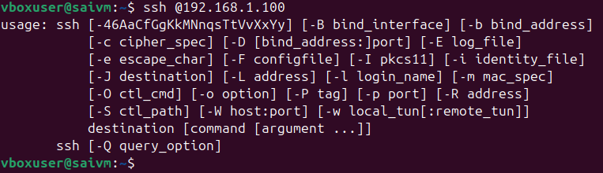

scp Command
Example: scp file.txt username@hostname:/path/to/destination
Description: The scp command is used for secure copy from one machine to another. In the example, file.txt is being copied to a remote host. The username@hostname specifies the user and host of the remote machine, and /path/to/destinationis where the file will be placed on the remote machine

Ex: scp file.txt user@remote_host:/remote/directory/

Working with the Bash Shell commands

tee
Example: ls | tee file.txt
Description: Used in pipes to direct the output of a command both to a file and the next command in the pipe.

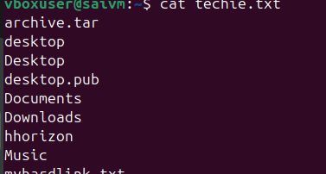

history
Example: history
Description: Displays a list of previously executed commands
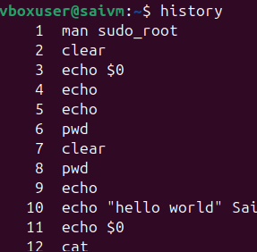

history -d
Example: history -d 1023
Description: Deletes a specific command from the history, where 1023 is the history entry number you want to remove.

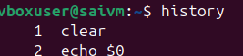
Delete btwn numbers 1-n
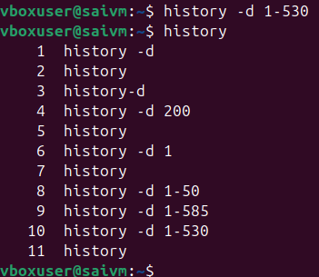

alias
Example: alias ll='ls -l'
Description: Creates a shortcut for a longer command. In this example, typing ll will execute ls -l.
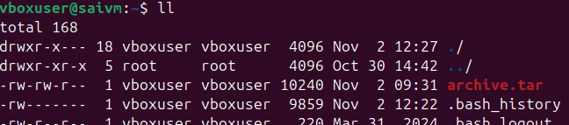
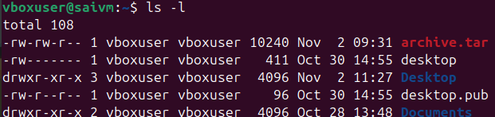

export
Example: export VAR=value
Description: Sets an environment variable VAR to a value value and makes it available to subshells
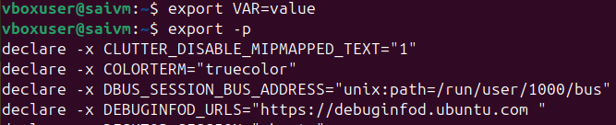
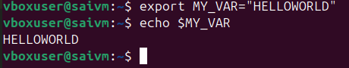

User and Group Management and Permissions Commands

useradd: Adds users.
Example: useradd johndoe
Description: Creates a new user account named 'johndoe'
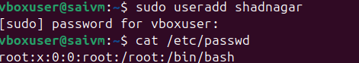
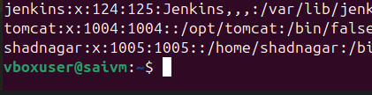
Use useradd if you want full control and are okay with manual steps. Use adduser if you want a quick, interactive way to add a user with default settings.

usermod: Modifies user properties.
Example: usermod -L johndoe
Description: Locks the user account 'johndoe'
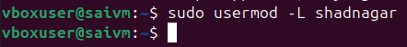
To check status of the user passwd -S shadnagar
To unlock the user usermod -U shadnagar
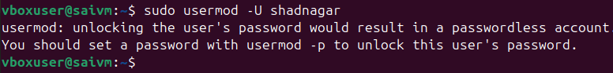

userdel: Deletes users.
Example: userdel johndoe
Description: Removes the user account 'johndoe'
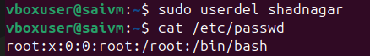
💡 Summary:
- 🧱 userdel → Basic system tool for removing users (works on all Linux).
- 🧩 deluser → User-friendly wrapper for Debian-based systems (Ubuntu, etc.).
groupadd: Adds groups.
Example: groupadd developers
Description: Creates a new group named 'developers'.
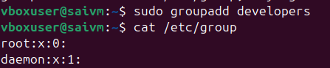
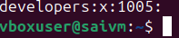
groupmod: Modifies group properties.
Example: groupmod -n newname oldname
Description: Renames a group from 'oldname' to 'newname'.

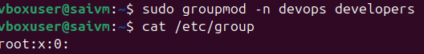
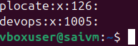

groupdel: Deletes groups.
Example: groupdel devops
Description: Removes the group named 'devops
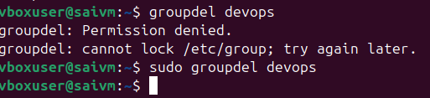
id: Shows information about user accounts.
Example: id johndoe
Description: Displays user and group IDs for 'johndoe'
getent: Gets information from administrative databases.
Example: getent passwd johndoe
Description: Retrieves user 'johndoe' details from the passwd database
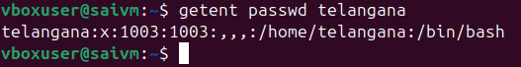
passwd: Changes passwords.
Example: passwd telangana
Description: Sets or changes the password for 'telangana'
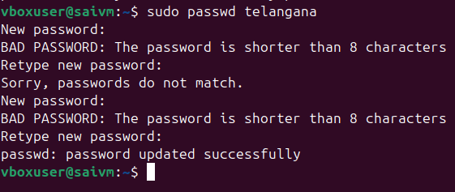

chage: Modifies password properties.
Example: chage -E 2023-12-31 johndoe
Description: Sets the expiry date of 'johndoe's password
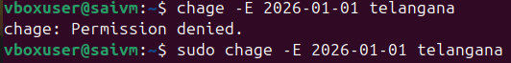
To view expiry date
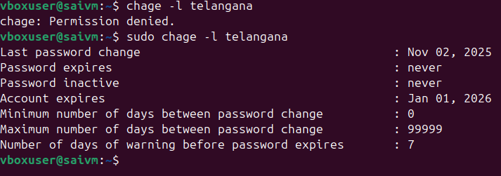

w: Shows logged-in users and details.
Example: w
Description: Lists users currently logged in with session details
who: Shows currently logged-in users.
Example: who
Description: Lists users currently logged in with minimal details
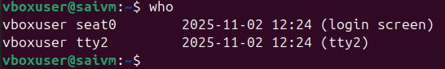

vipw: Edits the passwd file.
Example: vipw
Description: Opens the password file for editing
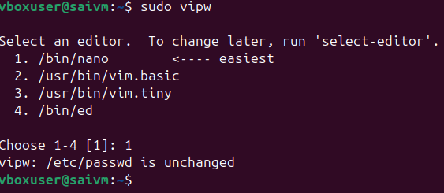
PASSWORD NOT CHANGED
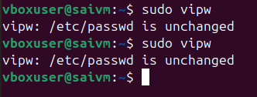
vigr: Edits the /etc/group file.
Example: vigr
Description: Opens the group file for editing
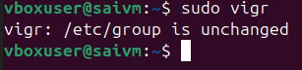
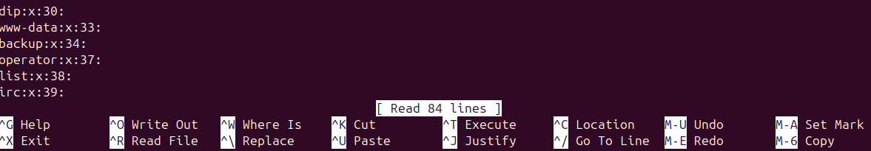
loginctl: Manages user sessions.
Example: loginctl list-sessions
Description: Lists current user sessions
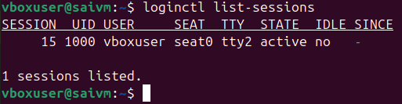
Permissions Management commands
chown
Example: chown user:group filename
Description: Changes the ownership of a file or directory. The command alters both user and group ownership. It's a versatile command that eliminates the need for chgrp in most cases
Change of directory
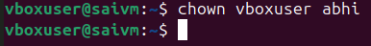
Change of group
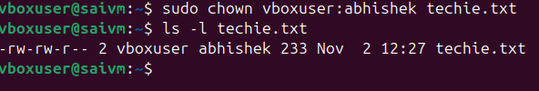
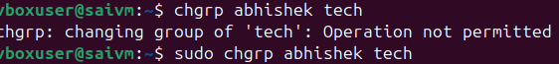
chgrp
Example: chgrp group filename
Description: Changes the group ownership of a file or directory. While this command is dedicated to changing group ownership, chown can also perform this function.

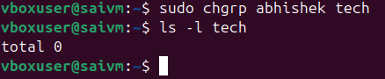
- Since ls -l shows total 0, it indicates that tech is a directory that contains zero blocks of data used by its contents (meaning it's empty).
In summary, the commands successfully changed the group ownership of the directory tech to abhishek, and the directory tech is currently empty.
chmod
Example: chmod 755 filename
Description: Changes the permission mode of a file or directory. It's an essential command for managing file and directory permissions in terms of read, write, and execute rights
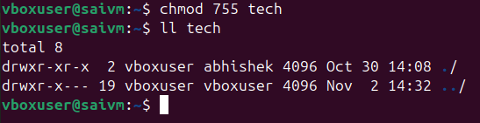
diff
Example: diff file1 file2
Description: Compares two files and displays the differences between them. This command is particularly useful in scenarios like checking changes in configuration files or script versions
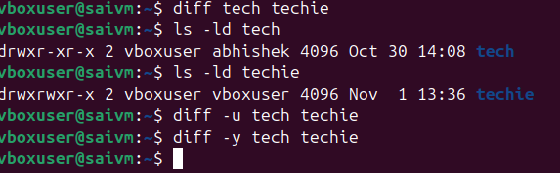
find (in the context of set user ID)
Example: find / -perm /4000
Description: Searches for files with set user ID permissions. This is important for security and system administration, to locate files that might have special privileges
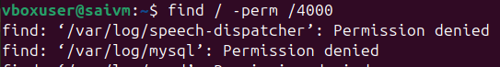
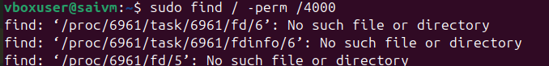

umask
Example: umask 022
Description: Sets the default permissions for newly created files and directories. It's a foundational command for establishing baseline security and access controls
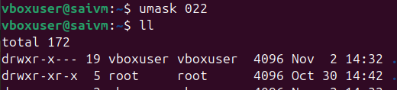

Storage Management Essentials commands
lsblk
Description: Lists all block devices.
Example: lsblk
This command displays information about all block devices connected to the system, such as hard drives and USB drives.
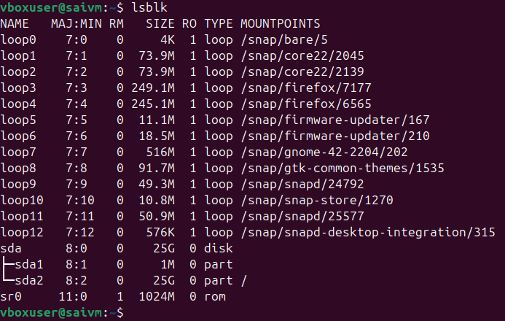

fdisk
Description: Manages partitions on an MBR disk.
Example: fdisk /dev/sda
Used for creating and managing disk partitions on an MBR (Master Boot Record) formatted disk
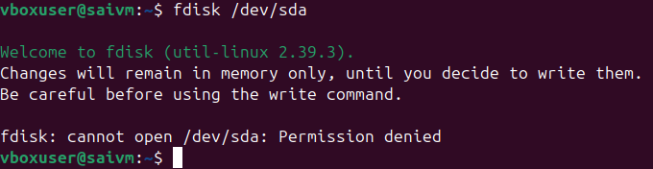
gdisk
Description: Manages partitions on a GPT disk.
Example: gdisk /dev/sda
Similar to fdisk but for GPT (GUID Partition Table) formatted disks, which are more modern
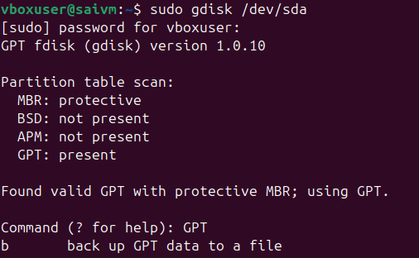

mkfs
Description: Creates a filesystem.
Example: mkfs.ext4 /dev/sda1
A generic utility to format a partition with a specific file system, such as ext4, xfs, or btrfs
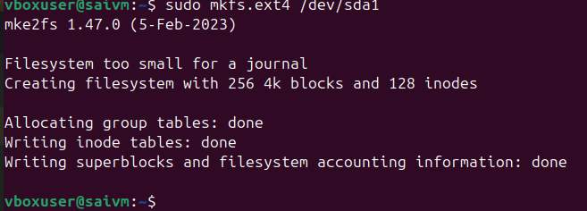

mount
Description: Attaches a filesystem to the file tree.
Example: mount /dev/sda1 /mnt
This command is used to mount a filesystem found on a device to a specific directory in the file tree.
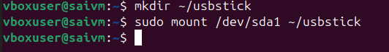

findmnt
Description: Lists mounted filesystems.
Example: findmnt
Provides a detailed overview of all the filesystems currently mounted in the system
umount
Description: Detaches the filesystem from the file tree.
Example: umount /mnt
Used to unmount a previously mounted filesystem
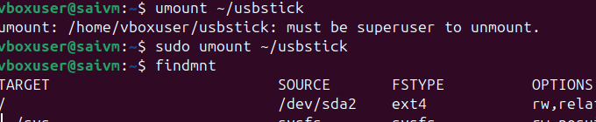
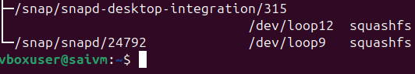

Lsof "List Open Files
Description: Lists open files and the processes using them.
Example: lsof /dev/sda1
Useful for diagnosing why a device might be busy, particularly if trying to unmount it and receiving a "device is busy" message
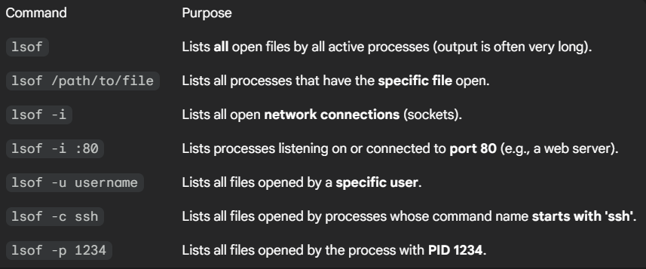
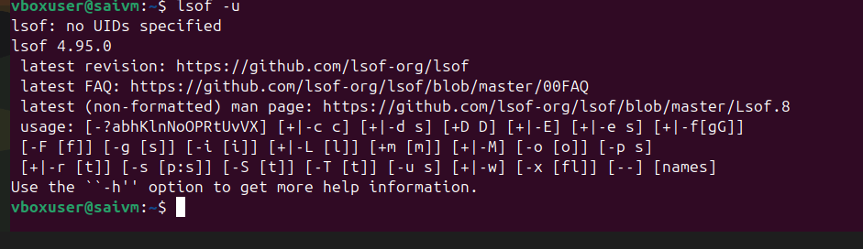
Command lsof -u username
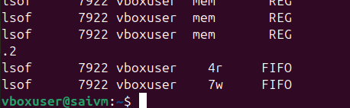

Managing Networking commands
Command: ip a
Example: ip a
Description: Prints current IP address information, showing the IP addresses assigned to all network interfaces.
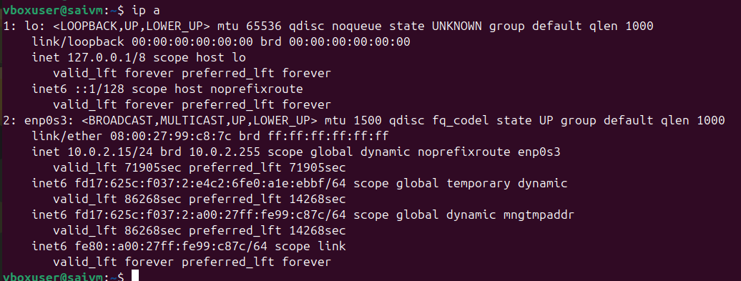

Command: ip route show
Example: ip route show
Description: Displays the routing table, including the default route, which is essential for understanding network routes.

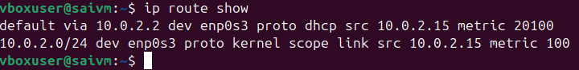
command: ping
Example: ping google.com
Description: Tests connectivity to a network host (e.g., a website like google.com) by sending ICMP packets
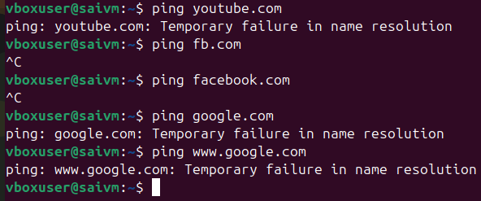
By using resolvectl status command we got some dns which are currently running
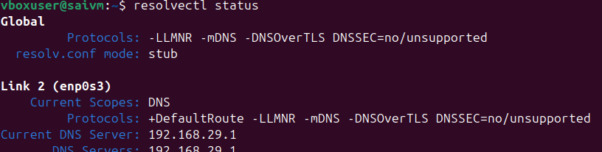

Then ping ipaddress

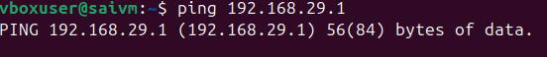

Command: ss
Example: ss -tuln
Description: Shows socket statistics. Used to check open ports and listening services on the system.
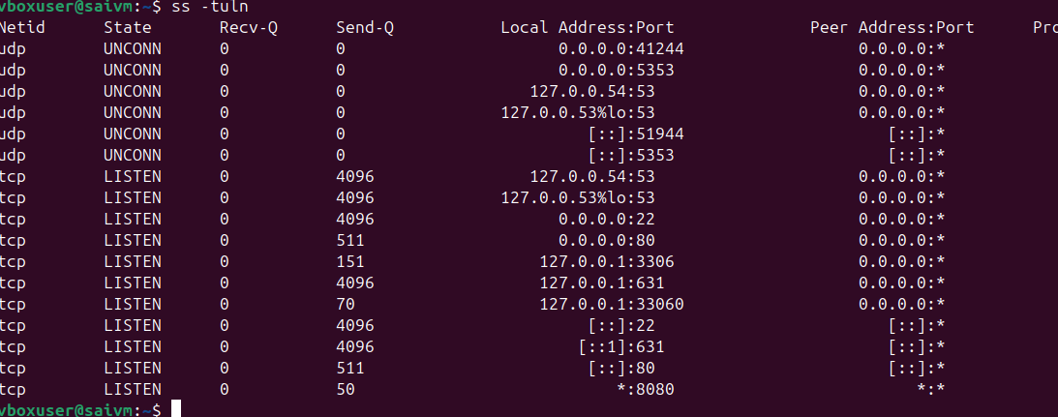

Command: dig domain information groper
Example: dig example.com
Description: Queries DNS information. It's useful for troubleshooting DNS issues or verifying DNS records.
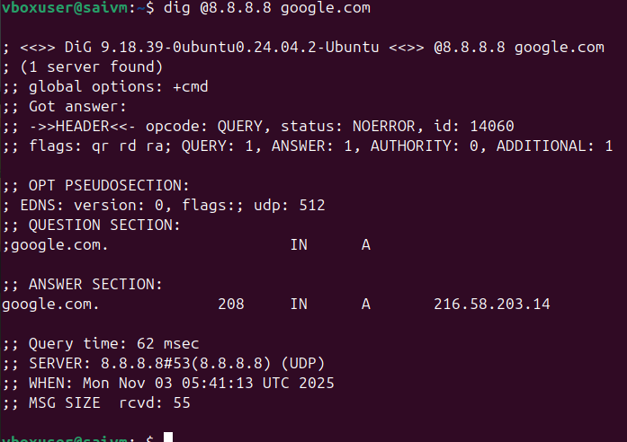
Command: nmap
Example: nmap -v 192.168.1.1
Description: An advanced security analysis tool that scans networks and systems for open ports, services, and other security vulnerabilities
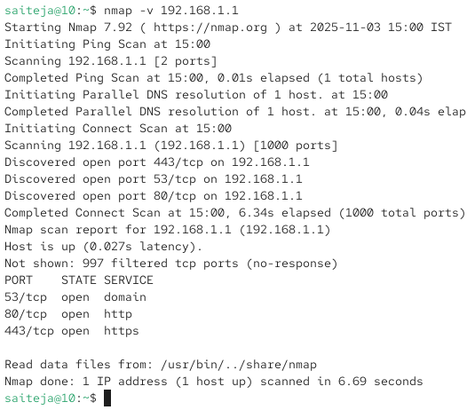

Command: hostname
Example: hostname
Description: Displays the system's host name.
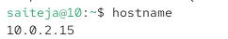
Command: hostnamectl
Example: hostnamectl set-hostname myhostname
Description: Used for host name management, including viewing and changing the system's hostname.
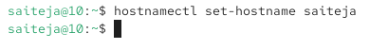
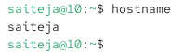

Working with Systemd commands
systemctl start or enable
Example: systemctl start httpd
Description: Starts a specified unit file
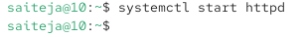

systemctl status
Example: systemctl status httpd
Description: Displays the current status of a unit file
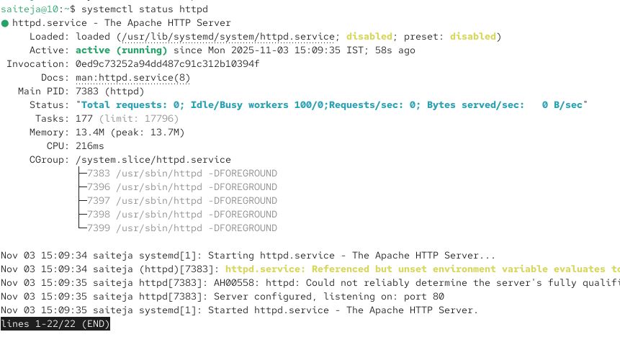

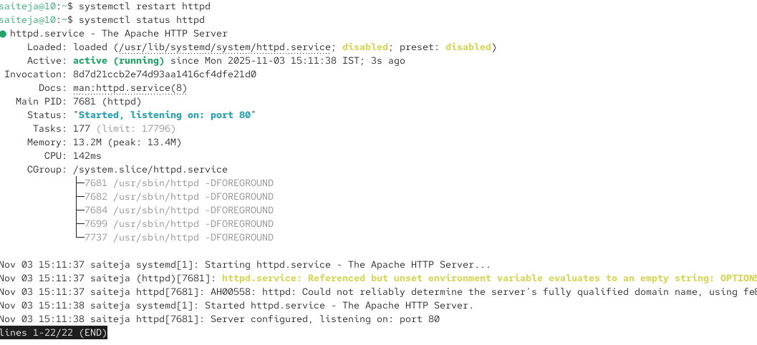
systemctl stop
Example: systemctl stop httpd
Description: Stops a running unit file
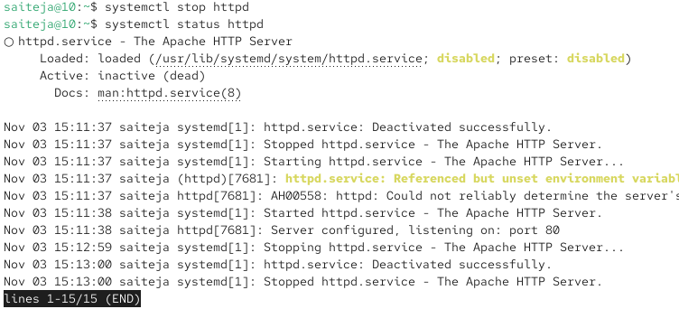
systemctl enable
Example: systemctl enable httpd
Description: Enables a unit file to start automatically on system boot and created sym link symbolic link

systemctl disable
Example: systemctl disable httpd
Description: Disables a unit file from starting automatically on boot and removes sym link
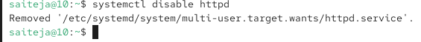

systemctl list-units
Example: systemctl list-units
Description: Lists all currently loaded unit files
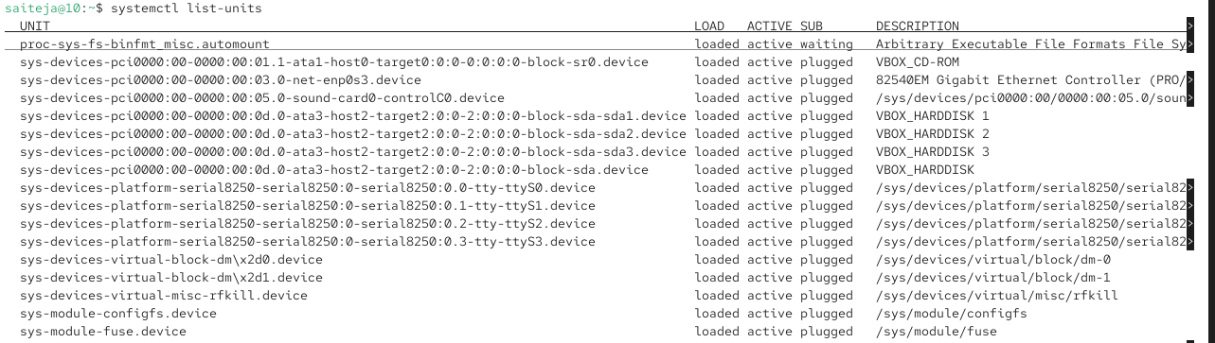

systemctl set-default
Example: systemctl set-default graphical.target
Description: Sets the default target that the system boots into


systemctl get-default
Example: systemctl get-default
Description: Displays the current default target
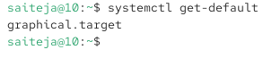

systemctl cat
Example: systemctl cat httpd
Description: Shows the configuration of a unit file

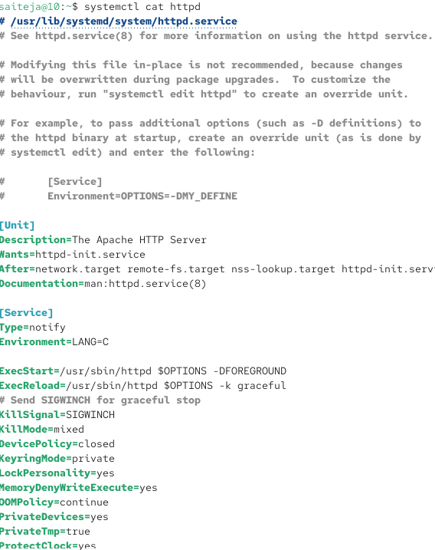

systemctl show
Example: systemctl show httpd
Description: Displays all the options set for a unit file
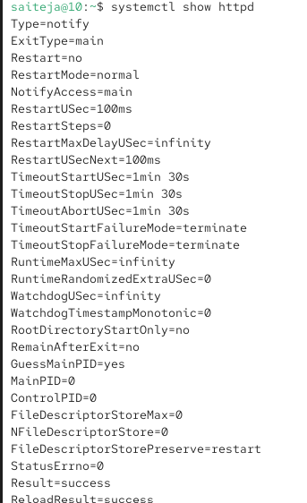
systemctl edit
Example: systemctl edit httpd
Description: Opens an editor to modify a unit file
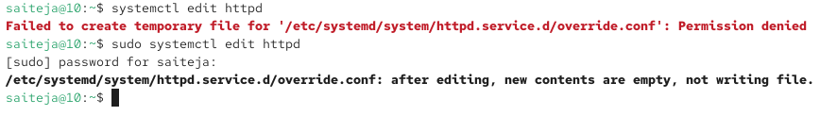

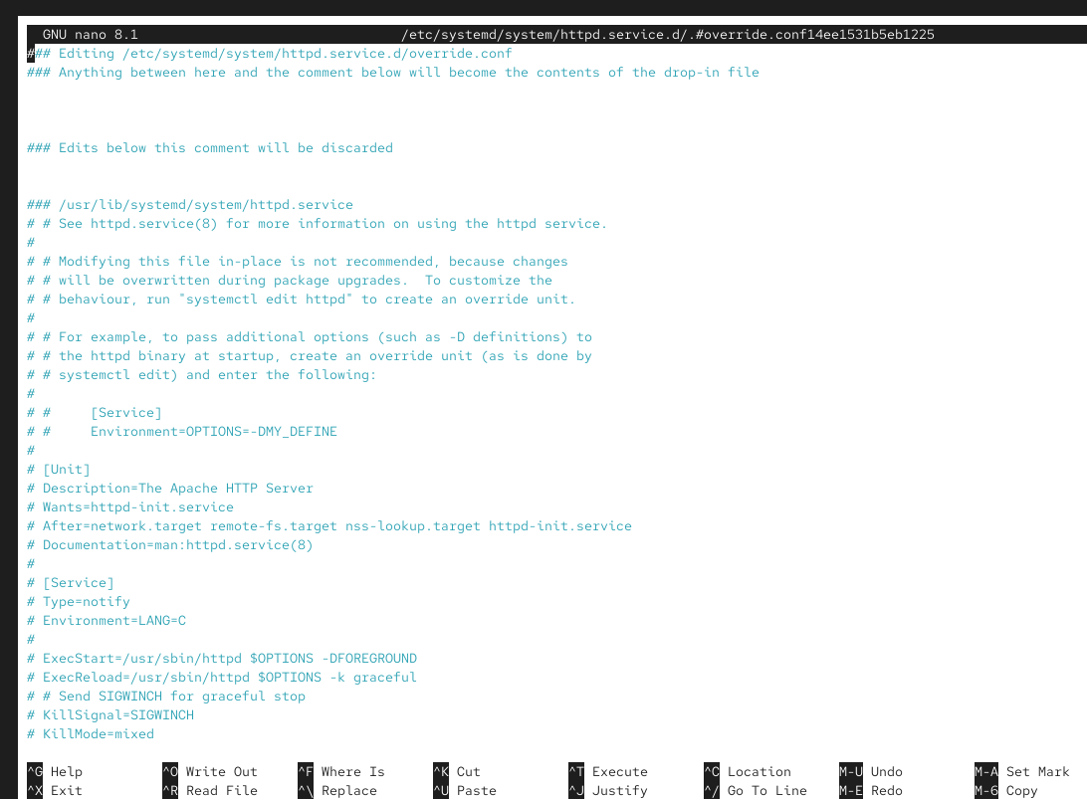

systemctl daemon-reload
Example: systemctl daemon-reload
Description: Instructs the systemctl main process to reload its configuration


systemctl isolate
Example: systemctl isolate graphical.target
Description: Switches the system to a different target
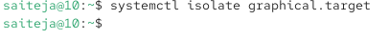

systemctl list-dependencies
Example: systemctl list-dependencies graphical.target
Description: Lists all dependencies of a specific target.
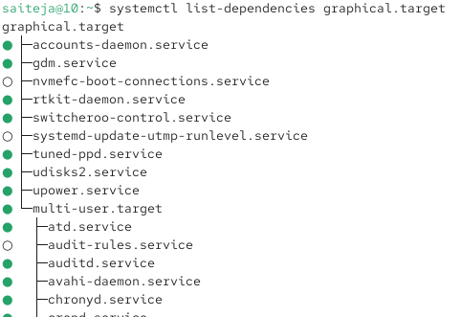

Managing Software Commands
Command: rpm
Description: Originally used for installing packages, rpm is now mainly used for querying information about installed packages.
Example: rpm -q package_name - This command queries details about a specific package
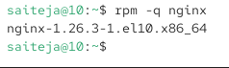
Command: yum
Description: yum is a software package manager used in Red Hat-based environments for installing, updating, and managing packages.
Example: yum install package_name - This command installs a specific package
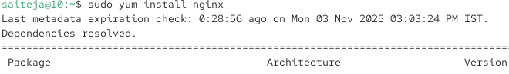

Command: dnf
Description: Similar to yum, dnf is a modern package manager for Red Hat-based systems, offering improved performance and package management capabilities.
Example: dnf update - This command updates all installed packages to their latest versions
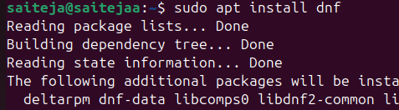

Managing SSH Commands
Change SSH Port on Ubuntu:
Command: sudo vim /etc/ssh/sshd_config
Description: Open the SSH configuration file using vim to change the SSH port
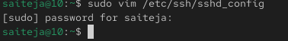
Update SSH Port to 2022:
: Change the line Port 22 to Port 2022 in the file.
Description: In the SSH configuration file, update the default port from 22 to 2022
Restart SSH Service:
Command: sudo systemctl restart sshd
Description: Restart the SSH daemon to apply the new configuration

Managing Time commands
Command: date
Example: date
Description: Displays the current date and time of the system. It's a basic and long-standing command in many operating systems.
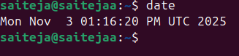
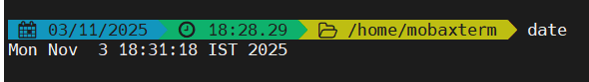
Command: hwclock
Example: hwclock --show
Description: Used for managing and viewing the hardware clock. It can also be used to synchronize the hardware clock with the system clock
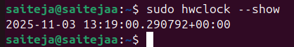

Command: timedatectl
Example: timedatectl status
Description: A modern utility for managing various aspects of time synchronization and settings. It can display and set time, date, and timezone, among other features
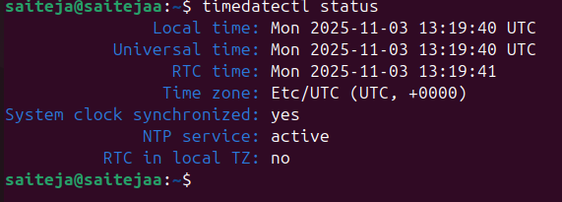
Command: chronyc
Example: chronyc tracking
Description: Interfaces with the chronyd time-synchronizing service, providing detailed information about the current synchronization status and more control over the chronyd service
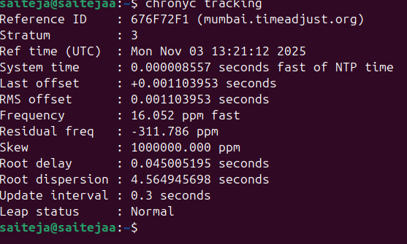

Process Management Commands
Command: top
Example: top
Description: Monitors all processes and the general health of the system from a performance perspective.
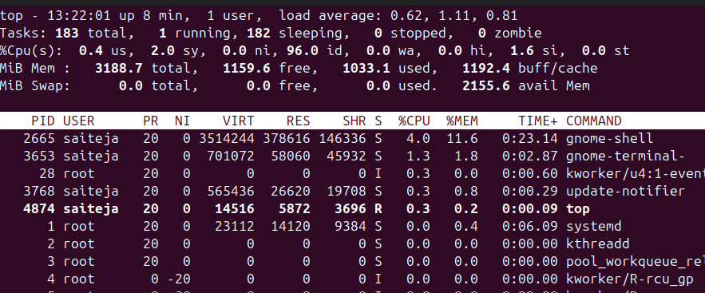
Command: ps
Example: ps aux
Description: Shows all processes and their properties; useful for monitoring system processes.
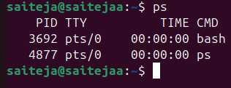
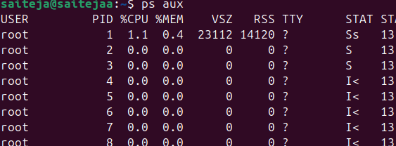
Command: jobs
Example: jobs
Description: Lists the jobs (processes) started by the user in the shell, allowing for management of interactive processes
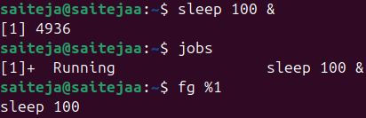
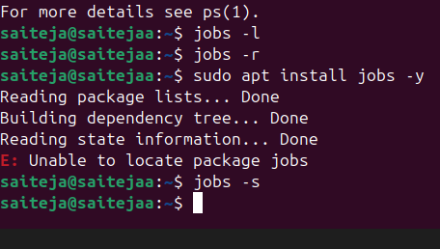

Command: fg
Example: fg %1
Description: Brings a job to the foreground, where %1 is the job number.
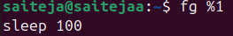
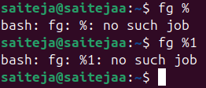

Command: bg
Example: bg %1
Description: Sends a job to run in the background
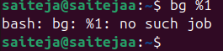

Command: nice
Example: nice -n 10 command
Description: Starts a process with a defined niceness (priority), where command is the command to be run with a priority.

Creating a bigfile of size 500 mb

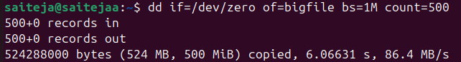
Run the command normally

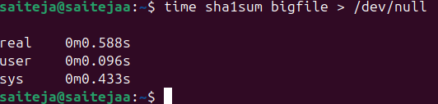
Run the same command with a lower priority

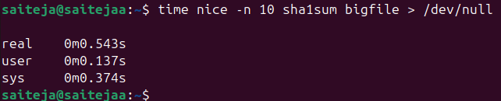

Check its niceness while running
In another terminal, run

Removing file
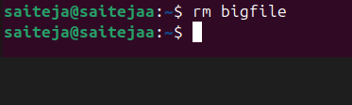
Command: renice
Example: renice -n 10 -p 1234
Description: Changes the priority of an already running process, where 1234 is the Process ID (PID).

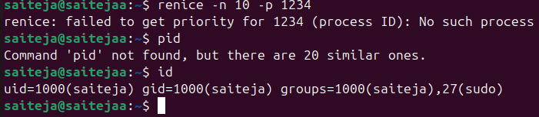
Command: killall
  - Example: killall processname
Description: Terminates all processes with the given name
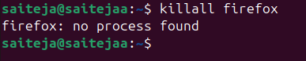

Scheduling Tasks Commands

at Command
Description: Allows you to schedule a job to run at a specific time.
Example: at 10:30 schedules a job to run at 10:30.

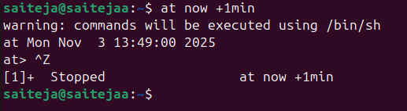

atq Command
Description: Displays a list of all jobs currently scheduled.
Example: atq shows all scheduled jobs with their job numbers
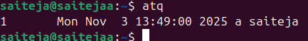

atrm Command
Description: Used to remove scheduled jobs.
Example: atrm 5 removes the job with the job number 5
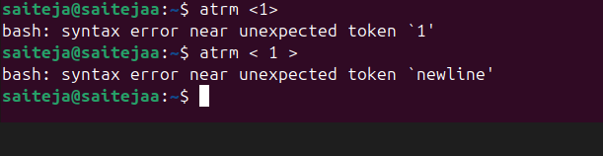

Editing Cron Configuration with crontab -e
Description: Opens the cron configuration for editing, allowing you to schedule jobs to run periodically.
Example: crontab -e opens the cron configuration file in a text editor.

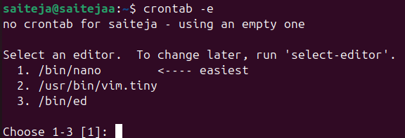
Working with Systemctl Timers Using systemctl
Description: Used to manage and interact with systemctl timers, a more systemwide approach for scheduling tasks.
Example: systemctl list-timers shows all active timers

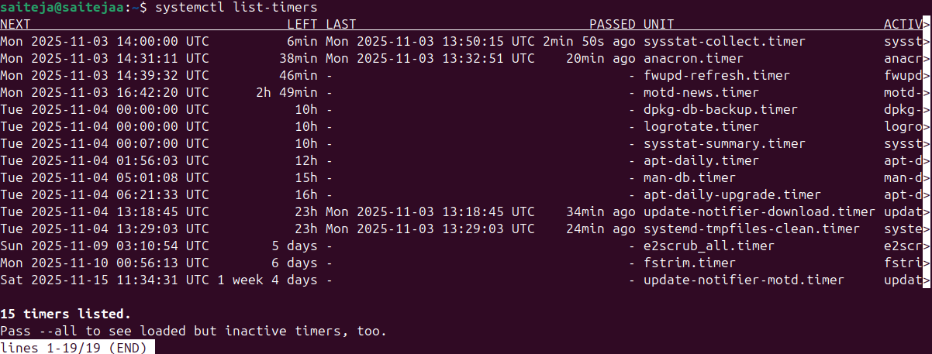

Reading Log Files Commands
command: journalctl
Description: This command is used to check the contents of the systemd journal, which is a centralized logging system for Linux.
Example: journalctl -u nginx.service
This example shows how to view logs for the Nginx service using journalctl
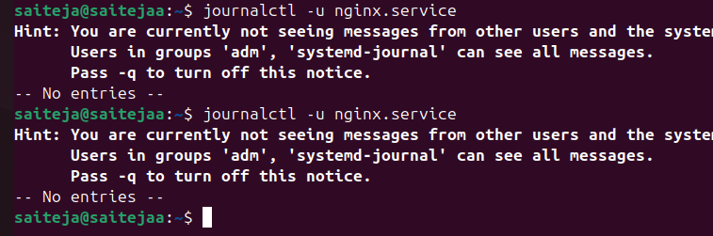
Command: tail
Description: The tail command is used to view the contents of log files, typically the last few lines.
Example: tail -n 100 /var/log/syslog
This example displays the last 100 lines of the syslog file
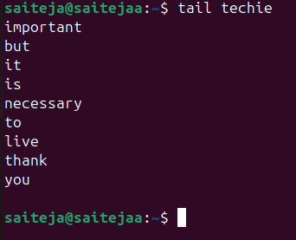
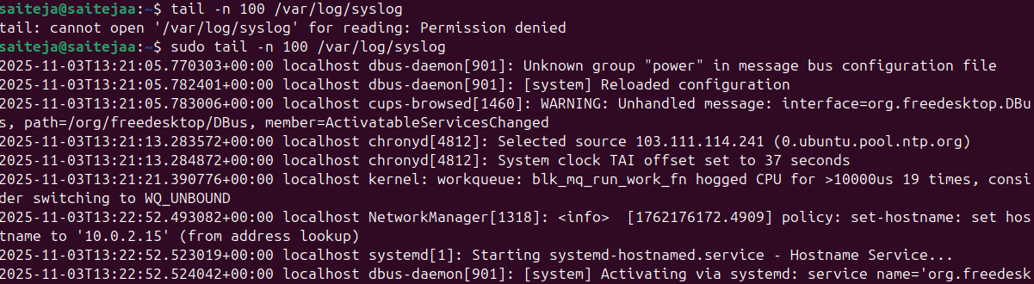
Command: less
Description: Similar to tail, less is used for viewing log files but allows for more controlled navigation through the file.
Example: less /var/log/apache2/access.log
This opens the Apache access log file in a scrollable interface for in-depth examination
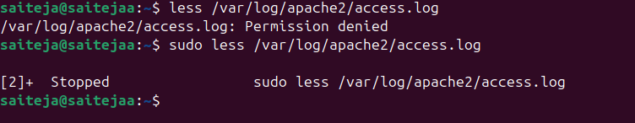

Adjust Firewall
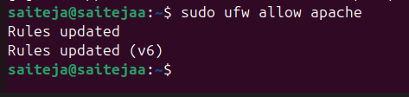
Command: logger
Description: The logger command is a convenient tool for writing messages to the system log.
Example: logger "System backup completed"
This example sends a custom message, "System backup completed," to the system log.
